Nathan Homer Knorr

Joseph Franklin Rutherford

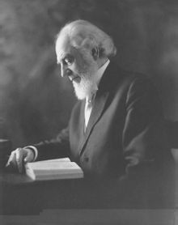 Charles Taze Russell

